# **Rich Sources of Potassium**

Everybody knows that potassium is important for a healthy body. But, not all of us know where we can get more potassium. One option, is to take a potassium supplement. Generally, this will get you all of the potassium that you need. However, the best source for potassium, is not from a supplement, but from the food you eat.

When you think about foods high in potassium, what immediately comes to mind? You probably thought of bananas, correct? Unfortunately, while bananas are a good source for potassium, there are many better food sources for potassium. Let’s take a closer look at the top thirteen foods with potassium.

1. **Swiss Chard**

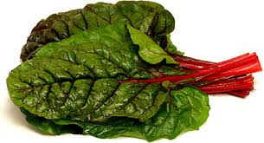  Hands down, Swiss chard is one of the most nutritious vegetables you can eat. This leafy green vegetable is literally packed with essential vitamins and nutrients. Consuming a mere 6 oz. of Swiss chard will give you more than you’re recommended daily amount of both vitamin K (700%) and vitamin A (200%).

It’s also a great source for vitamin C, magnesium, iron and manganese. Swiss chard is our vote for the best potassium food for you to add to your diet. Just one serving will provide you with approximately 27% of your daily recommended needs.

1. **Spinach**

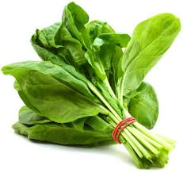

  Spinach is another nutrient-dense leafy green that is [extremely beneficial](http://www.whfoods.com/genpage.php?tname=foodspice&dbid=43) to you. It’s not only rich in many vitamins and minerals, it’s also a great source for phytonutrients and flavonoids that provide antioxidant defense. Consuming 6 oz. of spinach will provide you with more than your recommended daily amount of both vitamin K (1000%) and vitamin A (325%).

Spinach is also a great source for folate, magnesium, vitamin C, calcium and manganese. When it comes to potassium, consuming 180g of spinach will provide you with approximately 24% of your daily recommended values, making it one of the best potassium foods you can add to your diet.

**3. Cremini Mushrooms**

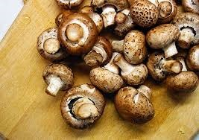 Cremini mushrooms come in as our pick for the third best potassium food. Just one cup of these delicious mushrooms will provide you will over 18 important vitamins, minerals and antioxidants. Be sure not to overcook these, as they will start to lose their nutritional values. Cremini mushrooms are an excellent source for selenium as just 8oz. will provide you with over 50% off your daily needs for selenium.

They are also a good source for riboflavin (vitamin B2), niacin (vitamin B3), zinc and copper. When it comes to potassium, one 8 oz. serving will give you approximately 18% of your daily needs.

**4**.**Tomatoes**

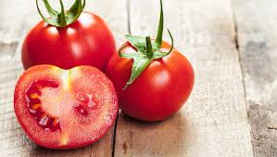  We’re all familiar with tomatoes. It’s a staple in diets around the world. They are a great source for lycopene, an antioxidant believed to have many health benefits. Antioxidants aren’t the only nutritional benefits of tomatoes.

They are also an excellent source for vitamin C, vitamin A, vitamin K, manganese and dietary fiber. When it comes to potassium, just one 8 oz. serving of tomatoes will give you approximately 12% of your daily recommended needs. Find the tomatoes that taste the best to you, and eat them regularly.

**5. Beets** 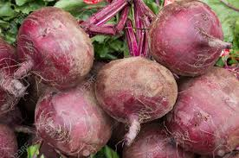

 It’s no surprise that beets are one of the best potassium foods, as they are classified in the same family as both Swiss chard and spinach. Beets are a great source for antioxidants, due to the red and yellow pigments naturally found in them. But antioxidants are the only thing beets are known for.

They are also a good source for folate, manganese, dietary fiber and vitamin C. When it comes to potassium, just one serving of beets will give you almost 13% of your daily recommended needs. Try to consume at least one beet every week.

**6. Yams**

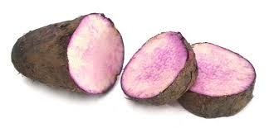  With approximately two hundred [varieties of yams](https://paleomagazine.com/types-of-sweet-potatoes-with-images-and-why-you-should-eat-them) to choose from, the nutritional benefits may vary. But generally speaking, just one cup of yams will provide you with optimal levels of vitamin C, manganese, vitamin B6 and dietary fibre. When it comes to potassium, just one cup of yams will give you approximately 26% off your daily needs.

We would recommend that you find a local farmer that sells yams and eat them at least twice a week.

**7. Cantaloupe**

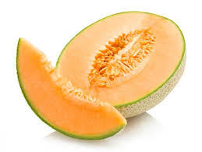 One of the most popular melons, the cantaloupe is another food high in potassium. While cantaloupes are a great source for potassium, the truth is that they make an even better diet food. This is due to the fact that it is very low in calories, despite its sweet aroma and flavor. Just one cup of raw cantaloupe will give you over 100% of your daily needs of vitamin A, plus 95% for vitamin C.

Other notable nutrients found in cantaloupe include folate, dietary fiber, vitamin K, magnesium and vitamin B6. When it comes to potassium, one cup of raw cantaloupe will provide you with approximately 12% of your daily needs.

**8. Carrots**

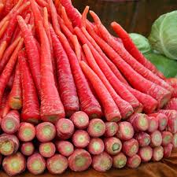  Probably best known as a great source for beta-carotene, carrots are actually a great source for many essential nutrients, including potassium. This popular root vegetable is commonly found in diets around the world, not only for their nutritional benefits, but also because they are relatively easy to grow. Just one cup of raw carrots will give you over 400% of your daily values for vitamin A.

Other notable nutrients found in carrots include vitamin K, vitamin C, vitamin B6, folate and manganese. When it comes to potassium, just one cup of carrots will give you approximately 11% of your daily needs.

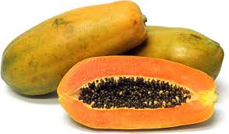**9. Papaya**

  This delicious tropical fruit is another great food high in potassium. Not only do they taste great and smell wonderful, but papayas are also a great source for many vitamins and minerals.

One unique, and beneficial, property of papayas is that they contain an enzyme called papain, which helps breakdown proteins to make them easier to digest. While papayas will vary in size and shape, the average piece of fruit will give you over 300% of your daily needs of vitamin C.

It’s also an excellent source for vitamin A, folate, vitamin E, vitamin K and dietary fiber. When it comes to potassium, one papaya will provide you with approximately 23% of your daily recommended values.

**10. Beans**

Commonly known for their high amounts of dietary fiber, beans and peas are also great sources for other essential vitamins and minerals. While there are many different varieties of beans and peas, they all make for great potassium foods. Here’s a breakdown of which beans and peas are the best sources for potassium:

* Lima Beans — 1 cup = 955mg of potassium (27% DV)
* Soy Beans — 1 cup = 885mg of potassium (25% DV)
* Pinto Beans — 1 cup = 745mg of potassium (21% DV)
* Kidney Beans — 1 cup = 716mg of potassium (20% DV)
* Lentils — 1 cup = 730mg of potassium (20.5% DV)
* Green Peas — 145 grams = 373mg of potassium (10% DV)
* Green Beans — 100 grams = 211mg of potassium (6% DV)

**11. Potatoes**

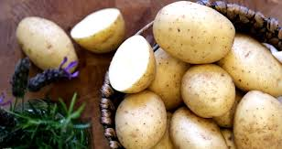 Another extremely popular vegetable around the world, potatoes are also a great source for potassium. However, it must be first noted that when you cover potatoes in butter, bacon or deep fry them, the potential health benefits are out-weighed by the potential health risks, no matter how delicious they may be.

One serving of potatoes (173 grams), will generally give you plenty of vitamin C, vitamin B6, tryptophan, manganese and dietary fiber. When it comes to potassium, just one serving of potatoes will give you approximately 26% of your daily needs.

**12. Avocado**

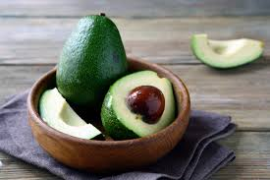  This creamy super-food is known to be high in many vitamins, minerals and healthy fats. Their best asset, besides its taste, is the fact that they are very high in dietary fiber. Avocados are also a great source for vitamin K, folate, vitamin C, vitamin B5 and vitamin B6. When it comes to potassium, just one cup of avocado will provide you with approximately 20% of your daily needs. You will not get this in your local grocery store but you can easily find from [BigBasket](http://couponwaale.in/offers/bigbasket).

**13. Bananas**

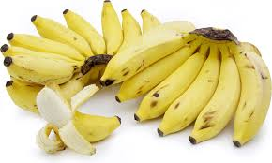  As we mentioned above, bananas are probably the most well-known food with potassium. But when you compare the numbers listed above, you’ll see that it’s not the best source for potassium, but that doesn’t mean you should stop eating them. Just one banana will give you plenty of vitamin B6, vitamin C, manganese and dietary fiber. Potassium ranks on the lower threshold, with only 12% of your daily needs in one banana.